Creative Technologies Project: Gamifying a Health and Fitness Apps for Young Adults – Final Report

**Author Name**Michael Ratcliffe

[michael2.ratcliffe@live.uwe.ac.uk](mailto:michael2.ratcliffe@live.uwe.ac.uk)

Supervisor: Lloyd Savickas [lloyd.savickas@uwe.ac.uk](mailto:lloyd.savickas@uwe.ac.uk)

Department of Computer Science and Creative Technology

University of the West of England  
Coldharbour Lane  
Bristol BS16 1QY

*Screenshot/ image of the work (600 pixels high x 800 pixels wide .jpg)  
This image is to be used for the degree show booklet. For white backgrounds please use 1/2pt black border.  
Also submit a copy of image file separately (600 pixels high x 800 pixels wide .jpg @ 240 dpi).*

**Abstract**

This project set out to test the viability of creating a health and fitness app for young adults using game design methods versus traditional design methods and explore possible uses for such an app, such as use within healthcare.

**Keywords**: gamification, apps, health, fitness**Brief biography**

Verdana, 9pt. A 70- 100 word section about you in relation to this project: how does this project link in with your professional skills, ambitions, interests, how will this project help you in your career. (not included in word count). Add a link to your online portfolio.

**How to access the project** (not included in word count)

Verdana, 9pt. Please put down the project URL and/or details of how to access your project, and the ***URL of your final video***. If we need to see any back end / administration interface please provide us with necessary passwords and URLs to access this. Basically, what we cannot access will not be considered for marking. You can change the passwords after you receive your mark.

We also want to be able to see source code, and the best way is to download it from your site or Github. Please clearly comment code to show us what is your own and what has been used from frameworks, libraries, OSS or borrowed from elsewhere.

If there is some other method for providing access to your project you will need to provide instructions here. Also if there is anything we need to know about the work that will not be self-explanatory, then also provide brief instructions here.

**1. Introduction** 400 words

The formatting for the main text is Verdana, 9pt.; the text should be justified, except for the references section and bibliography. Sub headings are 9pt bold. Avoid writing in first person, focus on the project instead.

Briefly introduce the project within its professional context. Tell us what it is about, what problems it solved, why it is important, interesting or valuable. What was it seeking to answer, how did it arise, why was it worth investigating?

* Also bullet list the
* key deliverables and
* project objectives here.

**2. Practice** 1500 words

State the main outcome(s) of the project. To help you do this, you can insert quotes, graphs, screenshots, diagrams, short code snippets etc. if useful and important.

| **Table example** | **1** | **2** | **3** |
| --- | --- | --- | --- |
| User 0 | 22.52 | 12.16 | 10.75 |
| User 1 | 22.72 | 12.26 | 10.60 |
| User 2 | 0.009 | 0.008 | 0.014 |

**Table 1:** Captionbelow the table, Verdana 8pt.

<p>   
For short code examples please use Courier Regular, 9pt. <br /> Larger code examples go in an appendix. Highlight code sections in colour if necessary.

</p>

Please note, all materials inserted need to be linked in with and discussed in the main text, like this hen (Fig 1); they cannot remain disconnected.

**Fig 1:** Captionbelow the image, Verdana 8pt. For white background use a 1/2pt border.

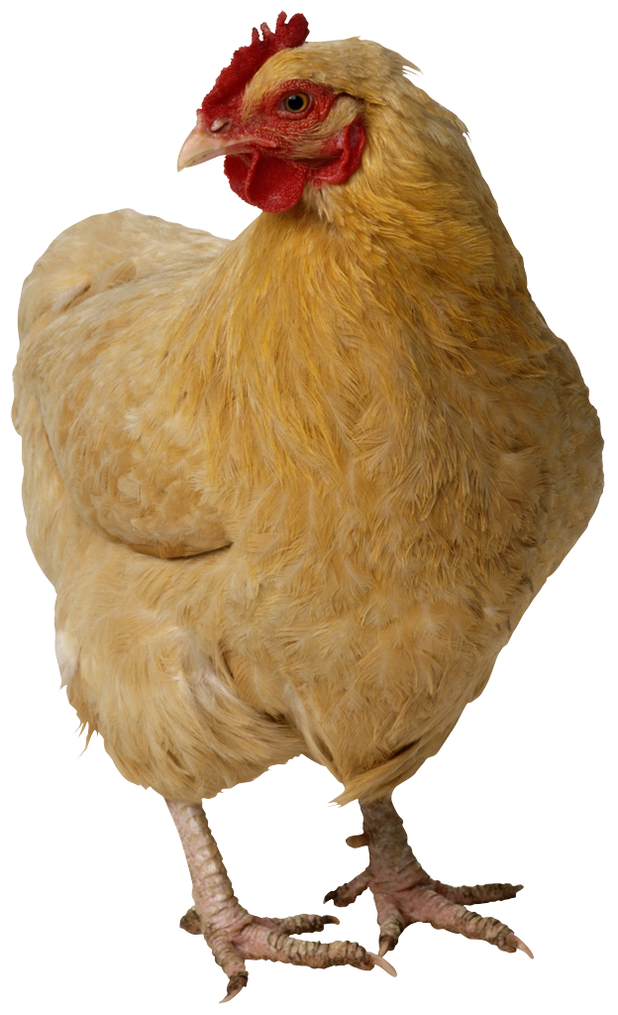

Reflect: How has the project developed *after* the research phase, and in hindsight how successful was its developmental phase? How did the research impact on the practice and vice-versa? How did user/ peer/ tutor feedback impact on it?

Evaluate: How successfully were problems encountered along the way being dealt with? Give us a few specific examples, not the whole story. These examples could be conceptual, technical, practical, legal (think copyright) or ethical (think user studies). Tell us how problems were overcome, or at least how every method was exhausted to arrive at the best possible solution.

**3. Discussion of outcomes** 900

Reflect: What significance does this completed project have in a wider professional context? What can other professionals draw from this project? What does it improve on? Critically analyse what has been achieved and if necessary suggest different future approaches.

You need some references here to link the project convincingly to its professional context. If you are new to UWE Bristol Harvard referencing please read the [introduction to referencing](https://www1.uwe.ac.uk/students/studysupport/studyskills/referencing/introduction.aspx). Click here for [how to refer to (cite) a work in your text](https://www1.uwe.ac.uk/students/studysupport/studyskills/referencing/uwebristolharvard/howtociteawork.aspx). Also here for [General advice on how to format quotations in your assignment](https://www1.uwe.ac.uk/students/studysupport/studyskills/readingandwriting/writing/formattingyourwork.aspx) (includes when to use quotation marks). Follow guidance here on how to reference the following: [books](https://www1.uwe.ac.uk/students/studysupport/studyskills/referencing/uwebristolharvard.aspx#books),  [journal articles](https://www1.uwe.ac.uk/students/studysupport/studyskills/referencing/uwebristolharvard.aspx#journalarticles), [films](https://www1.uwe.ac.uk/students/studysupport/studyskills/referencing/uwebristolharvard.aspx#films), [television programmes](https://www1.uwe.ac.uk/students/studysupport/studyskills/referencing/uwebristolharvard.aspx#television), [images and illustrations](https://www1.uwe.ac.uk/students/studysupport/studyskills/referencing/uwebristolharvard.aspx#imagesandillustrations), [official publications](https://www1.uwe.ac.uk/students/studysupport/studyskills/referencing/uwebristolharvard.aspx#officialpublications), [web pages](https://www1.uwe.ac.uk/students/studysupport/studyskills/referencing/uwebristolharvard.aspx#webpages).

Reflect: how and to what extent does the final stage of your practice connect with what it set out to do. You want to underline the achievements of the project here, but at the same time not hide any obvious omissions/ problems.

Reflect: What makes this project *original* in a professional sense; e.g. have you discovered any new methods as you went along? New models that might help others understand processes better? Perhaps you’ve developed a good protocol for implementing things? Streamlined some process?

**4. Conclusion and recommendations** 200

This section should not contain any new information. Here conclusions are drawn from the research and practical work that was completed. Does this project have a longer-term future beyond UWE and if so what might it look like?

Think about the impact it could be achieved in the wider field. How might it benefit users, professionals, society? Perhaps make some recommendations for further work.

**5. References** (=not included in word count – these are the sources you are actually quoting in this report; in alphabetical order)

Allan A, Schneider B and Miller C 2015 *Journal Name* **37** 074203

Bertrand J and Banes C 2009 *Journal Name* **23** 544

**Bibliography** (=not included in word count – these are other items you have read around this topic; in alphabetical order)  
Author, A. (2009) *A Book About Student Projects*. Location Publisher.

Author, B (2008) ‘Journal Article’, *Digital Media Journal*, Vol 1/13, pp 13-23

University of the West of England (2009) *UWE Library Services:Study skills - The Harvard System* [Online] Available from <https://www1.uwe.ac.uk/students/studysupport/studyskills/referencing/uwebristolharvard.aspx>

[last access: 23 September 2009]

**Appendix A: Project Log** (not included in word count)

**Appendix B: Project Timeline** (not included in word count)

**Appendix C: Title title title** (not included in word count)  
If necessary, insert further mateirals such as: a list of interview questions, any larger tables, evidence of design development, longer code snippets or other relevant materials in here or in further Appendixes. This does not come under the wordcount. Nevertheless, only insert useful materials here, please don’t just bulk this report up. Your main text should be able to stand on its own, without relying on information contained in appendixes!